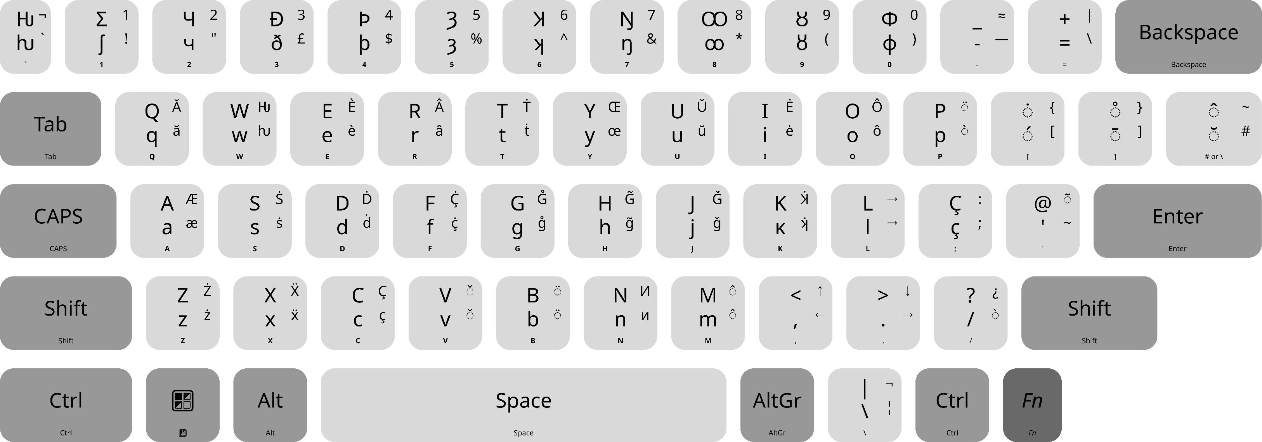NewEng Keyboard Layout v7.2

**NumRow key sequence**:

|  |  |  |  |  |  |  |  |  |  |  |
| --- | --- | --- | --- | --- | --- | --- | --- | --- | --- | --- |
| ` | 1 | 2 | 3 | 4 | 5 | 6 | 7 | 8 | 9 | 0 |
| **Ƕ ƕ** | **Ʃ ʃ** | **Ч ч** | **Ð ð** | **Þ þ** | **Ȝ ȝ** | **Ʞ ʞ** | **Ŋ ŋ** | **Ꝏ ꝏ** | **Ȣ ȣ** | **Φ φ** |
| *hwair* | *esh* | *chee* | *thee* | *eth* | *yogh* | *echo* | *eng* | *dub-o* | *uwow* | *phi* |

**Extra diacritics on [AltGr]**

|  |  |  |
| --- | --- | --- |
| ǒ | ö | ô |
| AltGr + v | AltGr + b | AltGr + m |
| ò |  |  |
| AltGr + /  AltGr + p |  |  |

**Main diacritics:**

|  |  |  |
| --- | --- | --- |
| ȯ | o̊ | ô |
| Shift + [ | Shift + ] | Shift + # |
| ó | ō | ŏ |
| [ | ] | # |

**Letters on [AltGr]**

|  |  |  |  |  |  |  |  |  |
| --- | --- | --- | --- | --- | --- | --- | --- | --- |
| **ă** |  | **è** | **â** | **ṫ** | **œ** | **ŭ** | **ė** | **ô** |
| q |  | e | r | t | y | u | i | o |
| **æ** | **ṡ** | **ḋ** | **ç̇** | **g̊** | **g̃** | **ġ** | **ʞ̇** |  |
| a | s | d | f | g | h | j | k |  |
| **ż** | **ẍ** | **ç** |  |  | **и** |  |  |  |
| z | x | c |  |  | n |  |  |  |